Personal Protective Equipment (PPE) for Workers in Construction Industry
Who Enter Confined Spaces – Quiz
This material was produced under grant number SH-39169-SH2 from the Occupational Safety and Health Administration, U.S. Department of Labor. It does not necessarily reflect the views or policies of the U.S. Department of Labor, nor does mention of trade names, commercial products, or organizations imply endorsement by the U.S. Government.

- Protective equipment includes personal protective equipment (PPE) for eyes, face, head, and extremities, protective clothing, respiratory devices, and protective shields and barriers.
  - True
  - False
- A confined space, is a space that:
  - Is large enough and so configured that an employee can bodily enter it.
  - Has limited or restricted means for entry and exit.
  - Is not designed for continuous employee occupancy.
  - All of the above
- PPE should be used whenever exposed to:
  - Hazards of processes or environment
  - Chemical hazards
  - Radiological hazards
  - Mechanical irritants
  - All of the above
- Which is not an acceptable hearing protection device?
  - Ear plugs
  - Plain cotton
  - Earmuffs
- PPE does not need to be inspected for signs of damage or wear prior to use.
  - True
  - False
- Employers must institute all feasible engineering and work practice controls to eliminate and reduce hazards before using PPE to protect against hazards.
  - True
  - False
- When cleaning PPE, the manufacturer’s instructions should always be followed.
  - True
  - False
- Safety belt lanyards shall be a minimum of 1/2 -inch nylon, or equivalent, with a maximum length to provide for a fall of no greater than 6 feet.
  - True
  - False
- Benefits of having a safety culture at the workplace include:
  - Commitment to safety and health
  - Cooperative atmosphere between management and employees
  - Better workplace morale and Improved recruitment and retention
  - All of the above
- The image below is an example of a:
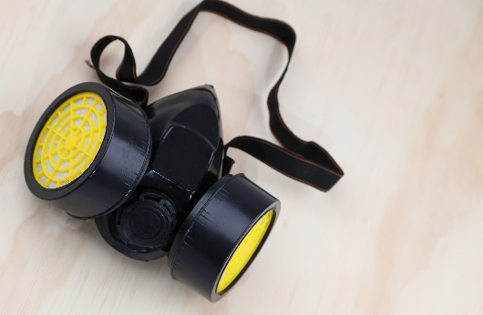
- Full face respirator
- Half face respirator
- N95
- SCBA

