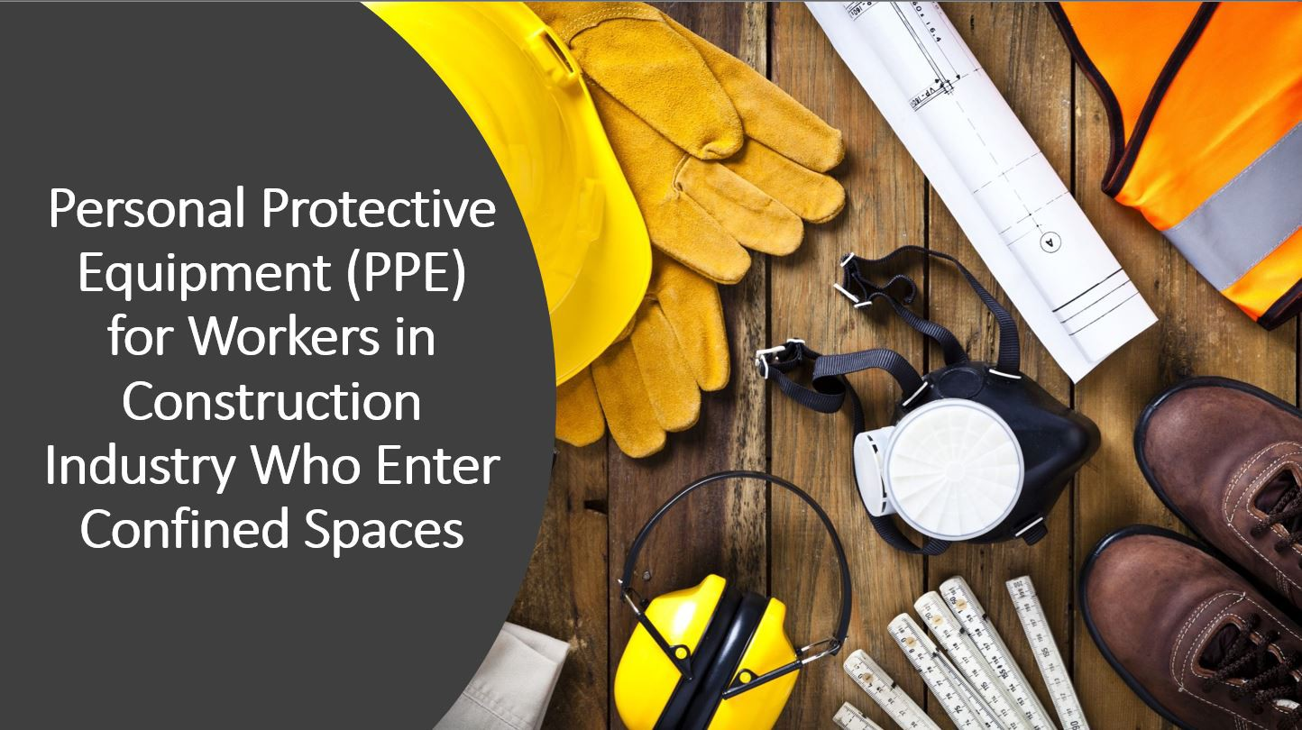

Personal Protective Equipment (PPE) for Workers in Construction Industry Who Enter Confined Spaces
1

Harwood Grant Disclaimer

This material was produced under grant number SH-39169-SH2 from the Occupational Safety and Health Administration, U.S. Department of Labor. It does not necessarily reflect the views or policies of the U.S. Department of Labor, nor does mention of trade names, commercial products, or organizations imply endorsement by the U.S. Government.
2

Introduction

- Accidents occur during confined space operations because employers fail to recognize hazards and establish control measures.
- It is critical that employers recognize and control hazards at the workplace.
- Although PPE is considered the least effective method, it is important to select the appropriate PPE for the specific hazard that workers encounter during their task.
3

Objectives
1
2
Understand worker Identify the
rights and employer requirements of a responsibilities PPE standard in
construction
3
Recognize common hazards that workers encounter during confined space operations that may require
use of PPE
4
Describe limitations, proper care and how to inspect PPE
5
Describe a behavior-based safety program and how to promote a safety culture
4

OSHA

OSHA’s Mission

With the Occupational Safety and Health Act of 1970, Congress created the Occupational Safety and Health Administration (OSHA) to ensure safe and healthful working conditions for workers by setting and enforcing standards and by providing training, outreach, education and assistance.
5

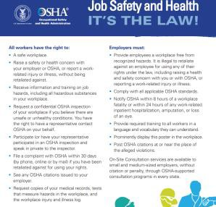
Worker Rights & Employer Responsibilities
6

OSHA’s Whistleblower Protection Program

An employer cannot retaliate against you for exercising your
rights under the Department of Labor’s whistleblower protection
laws.

https://www.osha.gov/sites/default/files/publications/OSHA3638.pdf
7

What is Retaliation?
- Retaliation occurs when an employer (through a manager, supervisor, or administrator) fires an employee or takes any other type of adverse action against an employee for engaging in protected activity.
  - Retaliation includes such actions as:
    - Firing
    - Laying off
    - Demoting
    - Denying overtime or promotion
    - Reducing pay or hours
- An adverse action is an action which would dissuade a reasonable employee from raising a concern about a possible violation or engaging in other related protected activity.

https://www.osha.gov/sites/default/files/publications/OSHA3638.pdf
8

Applicable Regulations
- 1926 Subpart C - General Safety and Health Provisions
https://www.osha.gov/laws-regs/regulations/standardnumber/1926/1926SubpartC
1926.28 - Personal Protective Equipment
https://www.osha.gov/laws-regs/regulations/standardnumber/1926/1926.28
  - The employer is responsible for requiring the wearing of appropriate personal protective equipment in all operations where there is an exposure to hazardous conditions or where the need for using such equipment to reduce the hazards to the employees.

- 1926 Subpart E - Personal Protective and Life Saving Equipment
https://www.osha.gov/laws-regs/regulations/standardnumber/1926/1926SubpartE
- 1926 Subpart AA - Confined Spaces in Construction
https://www.osha.gov/laws-regs/regulations/standardnumber/1926/1926SubpartAA
9

Definitions

- Protective Equipment- includes personal protective equipment (PPE) for eyes, face, head, and extremities, protective clothing, respiratory devices, and protective shields and barriers
  - Example: glasses, face shield, hard hats, N95, earplugs

- Confined space- a space that:
  - Is large enough and so configured that an employee can bodily enter it;
  - Has limited or restricted means for entry and exit; and
  - Is not designed for continuous employee occupancy
10

Criteria for Personal Protective Equipment (PPE)

Personal Protective equipment (PPE) shall be provided, used, and maintained in a sanitary and reliable condition wherever it is necessary by:
- hazards of processes or environment
- chemical hazards
- radiological hazards
- mechanical irritants
Encountered in a manner capable of causing injury or impairment in the function of any part of the body through absorption, inhalation or physical contact.
11

Employee - Owned Equipment

Where employees provide their own protective equipment, the employer shall be responsible to assure its adequacy, including proper maintenance, and sanitation of such equipment.
12

Design of the Equipment

All personal protective equipment shall be of safe design and construction for the work to be performed.
13

Payment for Protective Equipment - Requirements

- The protective equipment, including personal protective equipment (PPE), used, shall be provided by the employer at no cost to employees
- The employer is not required to pay for non-specialty safety-toe protective footwear (including steel-toe shoes or steel-toe boots) and non-specialty prescription safety eyewear, provided that the employer permits such items to be worn off the job-site
- When the employer provides metatarsal guards and allows the employee, at his or her request, to use shoes or boots with built-in metatarsal protection, the employer is not required to reimburse the employee for the shoes or boots

Review Handout: https://www.osha.gov/sites/default/files/Handout_2_Employers_Must_Provide_and_Pay_for_PPE.pdf
14

Payment for Protective Equipment

The employer is not required to pay for:
- Everyday clothing, such as long-sleeve shirts, long pants, street shoes, and normal work boots; or
- Ordinary clothing, skin creams, or other items, used solely for protection from weather, such as winter coats, jackets, gloves, parkas, rubber boots, hats, raincoats, ordinary sunglasses, and sunscreen
15

Payment for Protective Equipment (continued)

- The employer must pay for replacement PPE, except when the employee has lost or intentionally damaged the PPE
- Where an employee provides adequate protective equipment, the employer may allow the employee to use it and is not required to reimburse the employee for that equipment
- The employer shall not require an employee to provide or pay for his or her own PPE, unless the PPE is excepted by the regulation
16

Training

- Employer shall instruct each employee in the recognition and avoidance of unsafe conditions and the regulations applicable to the work environment to eliminate or control any hazards or other exposure to illness or injury
17

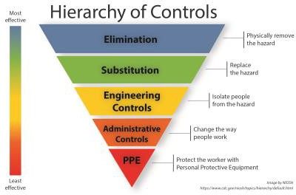
Recognizing Hazards and Protecting Employees

Employers must institute all feasible engineering and work practice controls to eliminate and reduce hazards before using PPE to protect against hazards.
18

Hazards

Common hazards that workers encounter in confined spaces:
Chemical |  | Heat |  |  | Impact
Compression |  | Penetration |  |  | Dust
 |  | Falls
19

1926 Subpart E
Personal Protective and Life Saving Equipment
20

1926 Subpart E - Personal Protective and Life Saving Equipment

- 1926.96 - Occupational foot protection
- 1926.100 - Head protection
- 1926.101 - Hearing protection
- 1926.102 - Eye and face protection
- 1926.103 - Respiratory protection
- 1926.104 - Safety belts, lifelines, and lanyards
- 1926.105 - Safety nets

https://www.osha.gov/laws-regs/regulations/standardnumber/1926/1926SubpartE
21

1926.96 Foot Protection

Standard Requirements: Safety-toe footwear for employees shall meet the requirements and specifications in American National Standard for Men's Safety-Toe Footwear, Z41.1-1967.
22

Foot Protection - Hazards

Common hazards in a confined space:
- Molten metal or welding sparks
- Impact and compression (heavy objects or tools that may roll, fall onto, or strike)
- Electrical hazards (exposed electrical wiring or components)
- Chemical hazards (corrosive chemicals)
- Wet or slippery surfaces
23

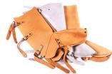
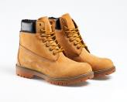
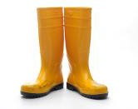
Foot Protection - Examples

Examples of PPE:
- Leggings
- Metatarsal guards
- Toe guards
- Safety shoes (boots)
- Rubber boots
24

Foot Protection Use and Care
Training: Use and care
How to properly put on the PPE.
How to adjust straps, laces, and other parts.
- Limitations of foot or leg protection: Poorly fitting safety shoes can result in bunions, corns, calluses, and other foot problems
- Inspection:
  - Scuffed, cracked, or lacerated uppers
  - Signs of separation between soles and uppers
  - Holes or cracks in soles or heels
  - Metal embedded in heels or soles or electrical hazard, safety-toe shoes
- Care: How to clean and maintain leg and foot protection?
25

- Why is foot protection necessary?
- Give examples of foot protection.
- What are some common confined space hazards that threaten feet or legs?
- How will foot protection protect you from the hazards in a confined space?
Let’s Review : Foot Protection

26

1926.100 - Head Protection

Standard Requirements:
Employees working in areas where there is a possible danger of head injury from impact, or from falling or flying objects, or from electrical shock and burns, shall be protected by protective helmets.
Criteria for head protection
- The employer must provide each employee with head protection that meets the specifications contained on the consensus standards
- The employer must ensure that the head protection provided for each employee exposed to high-voltage electric shock and burns also meets the specifications
27

Head Protection – Common Hazards

Common hazards in a confined space:
- Objects or tools may fall from above and strike the head
- Low hanging objects or protruding objects (ex: exposed beams or pipes)
- Working with or near exposed electrical wiring or components
28

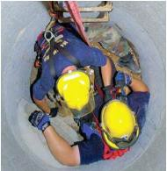
Head Protection - Examples

Example of PPE:
- Hard hats

Characteristics:
  - Resist penetration by objects
  - Absorb shock
  - Water resistant
29

Head Protection (continued)

Workers should:

- Read the instructions
- Check the hard hat label for the appropriate class
- Use and adjust hard hats properly
- Replace the suspension and head band (if needed)
- Not alter or modify hard hats
30

Class | Electrical Protection | Description
E - Electrical | Up to 20,000 volts | Protect against falling objects and high-voltage shock and burns
G - General | Up to 2,200 volts | Good impact protection but limited voltage protection
C - Conductive | Offers no electrical protection | Designed for comfort, offers limited protection

31
Head Protection - Classifications
Classification: Use of hard hat (electrical protection)
American National Standards Institute in ANSI Z89.1, which provides overall
standards for certification of head protection. https://blog.ansi.org/2016/06/ansiisea-z891-industrial-head-protection/#gref
Head Protection – Classifications (continued)
Classification: Protection of the Hard Hat

Type | Protection
I | Protects the top of the head from impacts (ex: falling objects)
II | Protects the top and lateral sections of the head from impacts (ex: bumping into a stationary object)

32

Head Protection – Use and Care
Training: Use and care
Video:
- How to wear the hard hat properly.
- Limitations of head protection: If objects are particularly • ^{How} ^{to} ^{adjust} ^{straps} ^{and}
heavy, or fall from a considerable height, your neck or
spine could still be damaged
- Inspection: How to identify signs of wear such as:
  - Cracked, torn, frayed, or otherwise deteriorated suspension systems;
  - Deformed, cracked, or perforated brims or shells; and
  - Flaking, chalking, or loss of surface gloss
- Care: How to clean and disinfect hard hats?
other parts.
33

34

- Why is head protection necessary?
- Give examples of head protection
- What are some common confined space hazards that threaten your head?
- How will head protection protect you from hazards in a confined space?
Let’s Review : Head Protection

1916.101-Hearing Protection

Standard Requirements:
- Wherever it is not feasible to reduce the noise levels or duration of exposures to those specified in Table D-2, Permissible Noise Exposures, in 1926.52, ear protective devices shall be provided and used
- Ear protective devices inserted in the ear shall be fitted or determined individually by competent persons
- Plain cotton is not an acceptable protective device
35

Duration per day, hours | Sound level dBA slow response
8 | 90
6 | 92
4 | 95
3 | 97
2 | 100
1½ | 102
1 | 105
½ | 110
¼ or less | 115
36
Table D-2 - Permissible Noise Exposures
In all cases where the sound
levels exceed the values in table D-2, an effective hearing conservation program shall be administered.

Hearing Protection

Common hazards in a confined space:
- Exposed to loud noise (machines, tools)

Note: Sounds generated by tools and heavy machinery can be magnified and reverberated within confined spaces.
37

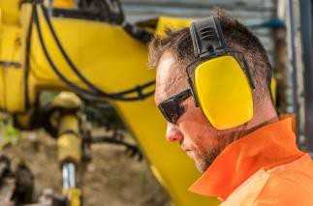
Hearing Protection - Examples

Examples of PPE:
- Earplugs
- Earmuffs
38

Hearing Protection – Use and Care

Training : Use and Care
- Limitations of hearing protection:
  - Earplugs - more difficult to insert and remove and may irritate the ear canal
  - Earmuffs - more uncomfortable in hot, humid work and more inconvenient for use in confined work areas. May interfere with the wearing of safety or prescription glasses.
- Inspection: How to identify signs of wear such as:
  - Broken or tear (plugs that are no longer pliable)
  - Check that head bands are not so stretched that they do not keep ear cushions snugly against the head
- Care: How to clean and disinfect hearing protection?

Video:
- When hearing protectors must be inserted.
- How to adjust hearing protection.

39

40

- Why is hearing protection necessary?
- Give examples of hearing protection
- What are some common confined space hazards that threaten hearing?
- How will head protection protect you from the hazards in a confined space?
Let’s Review : Hearing Protection

1926.102- Eye and Face Protection

Standard Requirements:
- The employer shall ensure that each affected employee uses appropriate eye or face protection:
  - when exposed to eye or face hazards from flying particles, molten metal, liquid chemicals, acids or caustic liquids, chemical gases or vapors, or potentially injurious light radiation
  - that provides side protection when there is a hazard from flying objects
41

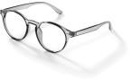
1926.102- Eye and Face Protection (continued)

Standard Requirements:
- The employer shall ensure that each affected employee who wears prescription lenses while engaged in operations that involve eye hazards wears eye protection that incorporates the prescription in its design, or wears eye protection that can be worn over the prescription lenses without disturbing the proper position of the prescription lenses or the protective lenses
42

Eye and Face Protection

Standard Requirements:
- Eye and face PPE shall provide adequate protection against the hazards for which they are designed
Shall be:
- Reasonably comfortable when worn under the designated conditions
- Fit snugly and shall not unduly interfere with the movements of the wearer
- Durable
- Capable of being disinfected and be easily cleanable
43

Eye and Face Protection - Criteria

Criteria for protective eye and face protection:
- Protective eye and face protection devices must comply with any of the following consensus standards:
  - ANSI/ISEA Z87.1-2010
  - ANSI Z87.1-2003, or
  - ANSI Z87.1-1989
44

Welding operation | Shade number
Shielded metal-arc welding 1/16-, 3/32-, 1/8-, 5/32-inch diameter electrodes | 10
Gas-shielded arc welding (nonferrous) 1/16-, 3/32-, 1/8-, 5/32-inch diameter electrodes | 11
Gas-shielded arc welding (ferrous) 1/16-, 3/32-, 1/8-, 5/32- inch diameter electrodes | 12
Shielded metal-arc welding 3/16-, 7/32-, 1/4-inch diameter electrodes | 12
5/16-, 3/8-inch diameter electrodes | 14
Atomic hydrogen welding | 10-14
Carbon-arc welding | 14
Soldering | 2
Torch brazing | 3 or 4
Light cutting, up to 1 inch | 3 or 4
Medium cutting, 1 inch to 6 inches | 4 or 5
Heavy cutting, over 6 inches | 5 or 6
Gas welding (light), up to 1/8-inch | 4 or 5
Gas welding (medium), 1/8-inch to 1/2-inch | 5 or 6
Gas welding (heavy), over 1/2-inch | 6 or 8
45
Eye and Face Protection – Radiant Energy
Protection against radiant
energy
Selection of shade numbers for welding filter
Table E-1 shall be used as a guide for the selection of the proper shade numbers of filter lenses or plates used in welding. Shades more dense than those listed may be used to suit the individual’s needs.
Table E-1-Filter Lens Shade Numbers for Protection Against Radiant Energy

Eye and Face Protection – Laser Protection

Laser Protection
- Employees exposed to laser beams shall be furnished suitable laser safety goggles which will protect for the specific wavelength of the laser and be of optical density (O.D.) adequate for the energy involved
- Table E-2 lists the maximum power or energy density for which adequate protection is afforded by glasses of optical densities from 5 through 8. Output levels falling between lines in this table shall require the higher optical density.
- All protective goggles shall bear a label identifying the following data:
  - The laser wavelengths for which use is intended
  - The optical density of those wavelengths
  - The visible light transmission
46
Eye and Face Protection – Laser Protection (continued)

Table E-2-Selecting Laser Safety Glass
Attenuation

Intensity, CW maximum power density  (watts/cm2) | Optical density (O.D.) | Attenuation factor
2  10- | 5 | 5  10
1  10- | 6 | 6  10
1.0 | 7 | 7  10
10.0 | 8 | 8  10

47

Eye and Face Protection – Common Hazards

Common Hazards in a Confined Space:
- Airborne dust or flying particles from cutting sanding, grinding, hammering
- Chemical splash of hazardous substances ( irritants, corrosives)
- Heat, glare, and sparks during welding operations
48

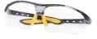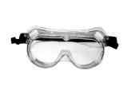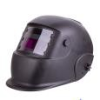
Eye and Face Protection – Examples of PPE

Examples of PPE:
- Safety glasses
- Goggles
- Face shield
49

Eye and Face Protection – Use and Care
Training: Use and Care
- Limitations of eye and face protection:
Video:
- How to put protective eyewear on properly
- How to adjust eye and face
- Safety glasses - provide minimal to no protection from ^{protection}
liquids or vapors
- Goggles - can fog when in use
- Face shields- do not protect employees from impact hazards
- Inspection: How to identify signs of wear such as:
  - Chipped, scratched, or scraped lenses
  - Loss of elasticity or fraying of head bands
- Care: How to clean and disinfect eye and face protection?
50

51

- Why are eye and face protection necessary?
- Give examples of eye and face protection
- What are some common confined space hazards that threaten the eyes and face?
- How will eye and face protection protect from hazards in a confined space?
Let’s Review : Eye and Face Protection

1926.103- Respiratory Protection

Standard Requirements:
The requirements applicable to construction work are identical to those in general industry - 29 CFR 1910.134.
- Written program
- Medical evaluation
- Fit testing
- Selection and use
- Maintenance and care
- Training
- Program evaluation
- Recordkeeping
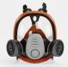
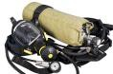
52

Respiratory Protection

Common hazards in a confined space:
- Lack of oxygen
- Working with chemicals hazards
- Toxic atmosphere hazards (dusts, fogs, fumes, mists, gases, smokes, sprays, fibers or vapors)
53

Respiratory Protection – Examples of PPE
Examples of PPE:
- Air-purifying respirators (APR) • Supplied-air respirators
  - Dust mask • Supplied air respirator
  - Half face • Abrasive blasting continuous
  - Full face flow
  - Loose-fitting powered air-purifying • Self-contained breathing respirator (PAPR) apparatus (SCBA)
  - Hood powered air-purifying respirator (PAPR)
54

Respiratory Protection – Use and Care
Training: Use and Care
- Limitations of the respiratory protection:
  - Air-purifying respirators (APR)
  - Supplied-air respirators
- Inspection: How to identify signs of wear such as:
  - Cracks, holes, tears, or breaks
  - Rippled or distorted facepiece edges
  - Fraying or deterioration of head strap/harness
- Care: How to clean and disinfect respiratory protection?
Video:
- How to put respiratory protection on properly
- How to adjust respiratory protection
55

- Why is respiratory protection necessary?
- Give examples of respiratory protection
- What are some common confined space hazards that threaten the respiratory tract?
- How will respiratory protection protect you from hazards in a confined space?
Let’s Review : Respiratory Protection

56

1926 Subpart E - Personal Protective & Life Saving Equipment

- 1926.104 - Safety belts, lifelines, and lanyards
https://www.osha.gov/laws-regs/regulations/standardnumber/1926/1926.104
- 1926.105 - Safety nets
https://www.osha.gov/laws-regs/regulations/standardnumber/1926/1926.105
57

Life Saving Equipment (continued)

- Any lifeline, safety harness, or lanyard actually subjected to in- service loading, as distinguished from static load testing, shall be immediately removed from service and shall not be used again for employee safeguarding
- Lifelines shall be secured above the point of operation to an anchorage or structural member capable of supporting a minimum dead weight of 5,400 pounds
Life Saving Equipment

- Lifelines, safety harnesses, and lanyards shall be used only for employee safeguarding
58

What is a Lifeline

- A lifeline is a component consisting of a flexible line for connection to an anchorage at one end to hang vertically (vertical lifeline) or for connection to anchorages at both ends to stretch horizontally (horizontal lifeline), and which serves as a means for connecting other components of a Personal Fall Arrest System (PFAS) to the anchorage
59

Safety Belts and Lanyards

- Safety belt and lanyard hardware shall be drop forged or pressed steel, cadmium plated in accordance with type 1, Class B plating specified in Federal Specification QQ-P-416. Surface shall be smooth and free of sharp edges.
- Safety belt and lanyard hardware, except rivets, shall be capable of withstanding a tensile loading of 4,000 pounds without cracking, breaking, or taking a permanent deformation
Lifelines

- Lifelines used in areas where the lifeline may be subjected to cutting or abrasion (example rock scaling operation), shall be a minimum of 7/8 -inch wire core manila rope
- For all other lifeline applications, a minimum of 3/4 -inch manila or equivalent, with a minimum breaking strength of 5,000 pounds, shall be used
61

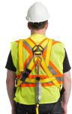
Safety Belt Lanyards

- Safety belt lanyard shall be a minimum of 1/2 -inch nylon, or equivalent, with a maximum length to provide for a fall of no greater than 6 feet
- The rope shall have a nominal breaking strength of 5,400 pounds
62

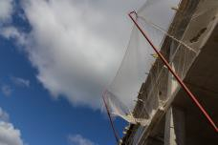
Safety Net Requirements

- Safety nets shall be provided when workplaces are more than 25 feet above the ground or water surface, or other surfaces where the use of ladders, scaffolds, catch platforms, temporary floors, safety lines, or safety belts is impractical
- Where safety net protection is required, operations shall not be undertaken until the net is in place and has been tested
64

Safety Net Requirements (continued)

- Nets shall extend 8 feet beyond the edge of the work surface where employees are exposed and shall be installed as close under the work surface as practical, but in no case more than 25 feet below such work surface
- Nets shall be hung with sufficient clearance to prevent user's contact with the surfaces or structures below. Such clearances shall be determined by impact load testing.
- It is intended that only one level of nets be required for bridge construction
65

Safety Nets

- The mesh size of nets shall not exceed 6 inches by 6 inches
- All nets shall meet accepted performance standards of 17,500 foot-pounds minimum impact resistance as determined and certified by the manufacturers and shall bear a label of proof test
66

Safety Nets (continued)

- Edge ropes shall provide a minimum breaking strength of 5,000 pounds
- Forged steel safety hooks or shackles shall be used to fasten the net to its supports
- Connections between net panels shall develop the full strength of the net
67

Behavior-Based Safety
68

What is a Behavior-Based Safety Program (BBS)

The Behavior-Based Safety (BBS) program:
- Takes in consideration of people’s attitudes, beliefs and feelings about safety at the workplace, and unearths the root causes of potential hazards and unsafe behaviors
- People are the most valuable resource
- People need the knowledge and confidence to make the right safety decisions
69

Employer’s Role

- Commitment to safety and health
- Promote a cooperative atmosphere between (employer) management and employees
- Allocate resources
- Provide motivation, direction, and actions
70

Behavior-Based Safety
Goals
Components
of behavior-
based safety
Positive
feedback
Buy-in
participation
71

Goals

- Set SMART monthly goals
- Incentivize when goals are met
72

Buy-in Participation

- Commitment from senior managers
- Lead by example
- Consistency – getting the same information into everyone’s hands
- Timeliness - share at the appropriate time
- Simplicity - mindset
73

Positive Feedback

- Reward system for smart safety decisions and practices
- Contributes to a positive workplace
- Helps to see the good in others
- Promotes employee engagement and safety culture
- Focus more on best work (choices)
74

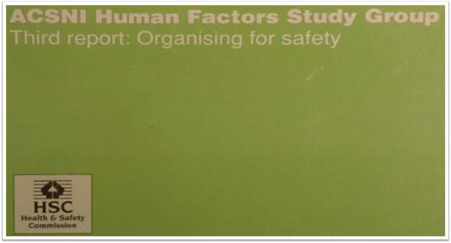
Definition: Safety Culture

“The safety culture of an organization is the product of individual and group values, attitudes, perceptions, competencies, and patterns of behavior that determine the commitment to, and the style and proficiency of, an organization’s health and safety management.
Organizations with a positive safety culture are characterized by communications founded on mutual trust, by shared perceptions of the importance of safety and by confidence in the efficacy of preventive measures.”
ACSNI Human Factors Study Group: Third report - Organizing for safety HSE Books 1993
75

Benefits of a Safety Culture

- Commitment to safety and health
- Cooperative atmosphere between management and employees
- Improvements in product, process, and quality
- Better workplace morale
- Improved recruitment and retention
- A more favorable image and reputation
76

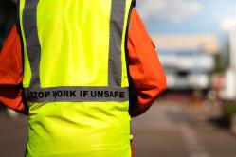
Core Elements for Safety Culture

- Management commitment
- Worker involvement
- Supervisor leadership
- Hazard identification and control
- Training
- Continuous improvement
77

Techniques to Promote Safety Culture

- Positive attitude
- Participation
- Ownership
- Flexibility
- Technology
78

Behavior-Based Safety and Safety Culture

- Safety culture does not happen by accident and is not one size fits all
- Safety culture is determined by how people feel, what people do, and
the organization’s safety policies and procedures (Cooper, 2000)
- An established behavior - based safety (BBS) program in construction is a powerful tool to improve the safety culture within a company
79

