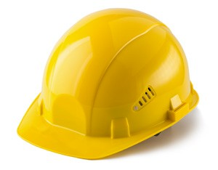
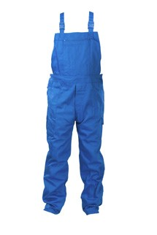
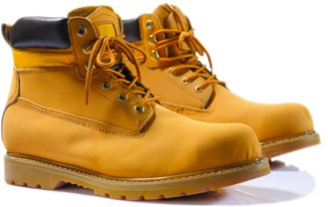
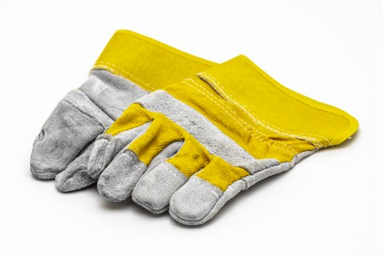
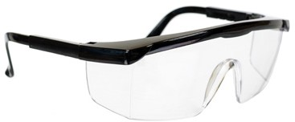
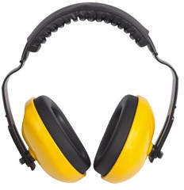
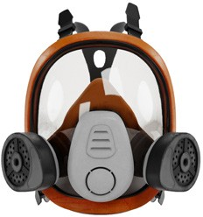
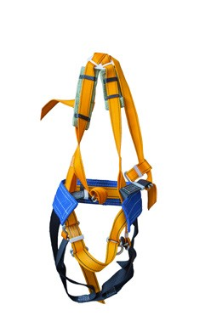
PERSONAL PROTECTIVE EQUIPMENT FOR CONFINED SPACES

Confined spaces present different hazards and degrees of risk to health and safety. The final provision of PPE should be based on a hazard assessment.

HARD HAT

SAFETY HARNESS

OVERALLS

RESPIRATORY PROTECTION
CONFINED SPACE PPE

SAFETY BOOTS

EARMUFFS OR EAR PLUGS

GLOVES

SAFETY GLASSES OR GOGGLES

This material was produced under grant number SH-39169-SH2 from the Occupational Safety and Health Administration, U.S. Department of Labor. It does not necessarily reflect the views or policies of the U.S. Department of Labor, nor does mention of trade names, commercial products, or organizations imply endorsement by the U.S. Government.

