EPA Masks Point of Distribution
UF/TREEO Center

Please note that only five (5) masks are allowed per Utility employee. The utility representative coming onsite should adhere to the Centers for Disease Control and Prevention (CDC) guidelines, which includes but is not limited to wearing masks and maintaining social distancing. Requests will be filled in the order that they are received until the supply is exhausted. If additional supplies are acquired, we will resume with the next order to be filled on the list.
Please complete the attached form with the following information and email it to rtrygar@treeo.ufl.edu with “Masks” in the subject line prior to visiting our facility because we have limited staff onsite.

- Utility Name
- Utility Contact/Email/Phone
- Utility Address
- PWSID/NPDES Permit #2
- Utility Type (W/WW)
- Utility Size/Number of Employees
- Quantity Requested
- Name(s) of Pickup Personnel
- Preferred Pick-up Date/Time

Pick up time will be between 7:00 AM and 3:00 PM, Monday through Friday unless previously arranged. Directions to the University of Florida TREEO Center are described below.
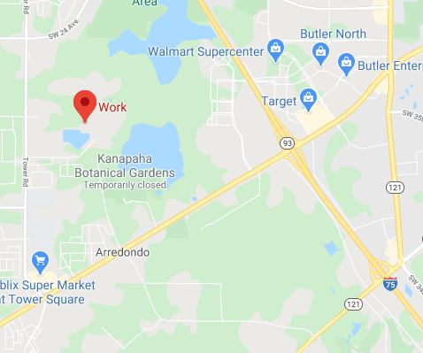
If you have any questions, please call Ron Trygar 850-284-6361 between 7:00 AM and 3:00 PM, Monday through Friday.

University of Florida TREEO Center
3900 SW 63rd Blvd.
Gainesville, FL 32608
- Map to TREEO Note: Be sure to use the UF/TREEO map because some internet maps will give you the wrong directions to get to our facility. Do not turn onto SW 63 from SR 24 (Archer Rd.) The road is closed just before you get to TREEO.

Disclaimer UF/TREEO is a distributor for EPA’s reusable mask distribution program only. We do not make any claims or warranties of the performance of these masks.
EPA Mask – North Central Florida distribution
Please complete and email this form to rtrygar@treeo.ufl.edu

EPA Masks Request Form
Utility Name
Utility Contact w/phone/email
Utility Address
PWSID/NPDES Permit #2
Utility Type (W/WW)
Number of Employees
Quantity of Masks (5 x # of employees)
Name(s) of Pickup Personnel
Pickup Date |  | Pickup Time

Signature Date

Disclaimer:
UF/TREEO is a distributor for EPA’s reusable mask distribution program only. We do not make any claims or warranties of the performance of these masks.

EPA Masks Point of Distribution
City of Pompano Beach
Utilities Department
1205 NE 5th Avenue
Pompano Beach, FL 33060

Please note that only five (5) masks are allowed per Utility employee. The utility representative coming onsite should adhere to the Centers for Disease Control and Prevention (CDC) guidelines, which includes but is not limited to wearing masks and maintaining social distancing. Proper identification is required to enter the facility and a copy of the identification will be kept on file. Requests will be filled in the order that they are received until the supply is exhausted. If additional supplies are acquired later, we will resume with the next order to be filled on the list.
Please fill out the attached form with the following information and email it to fumiko.ojiro@copbfl.com with “Masks” in the subject line prior to visiting our facility.
- Quantity Requested
- Utility Name
- Address
- PWSID/NPDES Permit #2
- Utility Type (W/WW)
- Utility Size / Number of Employees
- Utility Contact
- Phone Number
- Email Address
- Name(s) of Pickup Personnel
Pick up time will be between 8:00 AM and 3:00 PM, Monday through Friday unless previously arranged.
Directions to the City of Pompano Beach Utilities Administration Building:
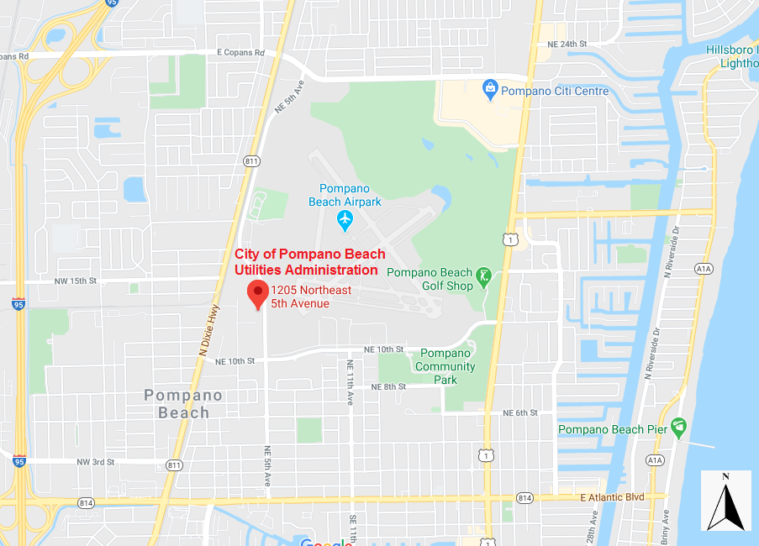
When approaching from north (E. Copans Road) or south (NE 10th Street) on NE 5th Avenue, look for the “Public Works & Utilities Administration” sign. Please park in any available parking spot. Overflow parking is available on the east side of NE 5th Avenue.
Our building is on the north side of the parking lot. Please ring the bell for service.
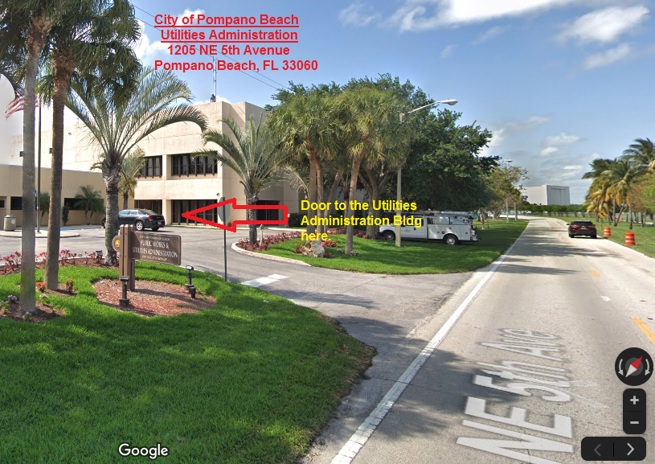
If you have any questions, please call Tammy Anderson at (954) 545-7016 between 8:00 AM and 3:00 PM, Monday through Friday.

Disclaimer:
The City of Pompano Beach is a distributor for EPA’s reusable mask distribution program only. We do not make any claims or warranties of the performance of these masks.

EPA Masks Request Form
Please fill out and send this form to fumiko.ojiro@copbfl.com.
Quantity Requested
Utility Name
Address
PWSID/NPDES Permit #2
Utility Type (W/WW)
Utility Size / # of Employees
Utility Contact
Phone Number
Email Address
Name(s) of Pickup Personnel
Signature Date

Disclaimer:
The City of Pompano Beach is a distributor for EPA’s reusable mask distribution program only. We do not make any claims or warranties of the performance of these masks.

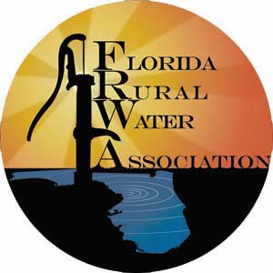
Florida Rural Water Association
2970 Wellington Circle
Tallahassee FL 32309
850.668.2746

Please drop by to get five (5) cloth masks for your utility employees. The utility representative coming onsite should adhere to the Centers for Disease Control and Prevention (CDC) guidelines, which includes but is not limited to wearing masks and maintaining social distancing.
Please complete the attached form and email it to frwa@frwa.net with “Masks” in the subject line prior to dropping by from 8:00 am – 5:00 pm, Monday through Friday, if possible. You will need:
- Utility name and Public Water System (PWS) ID number
- Name (s) of pickup personnel
- Number of employees at your Utility
- Quantity of masks (5 x number of employees)

Please stay safe and well to continue to provide appreciated public health protection to Florida.
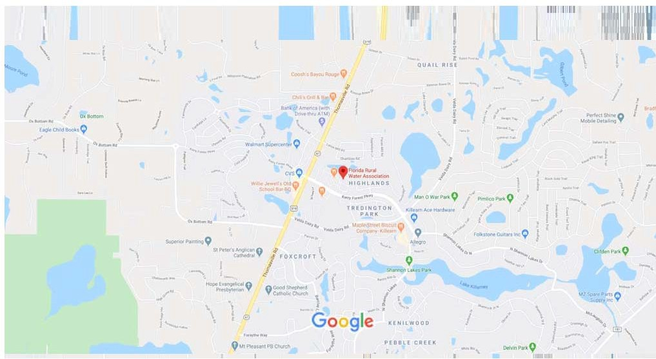
If you have any questions, please call FRWA at 850.668.2746 between 8:00 am and 5:00 pm, Monday through Friday.

The masks are being provided by EPA/Federal Government for critical infrastructure employees. FRWA is only a distribution point and provides no assurance of their eﬀectiveness. Please pickup your order at the table under the pop‐up shelter and fill out form if unmanned or come inside.

call 800.872.8207 to let us know when you will arrive.

EPA Masks Request Form
Utility Name
PWSID
Name(s) of Pickup Personnel
Number of Employees
Quantity of Masks (5 x # of employees)
Pickup Date |  | Pickup Time

SIGNATURE

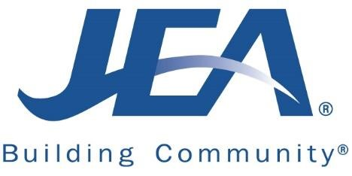
EPA Masks Distribution

Please note that only five (5) masks are allowed per Utility employee.
Please fill out the form below and email it to dimeea@jea.com with “EPA Masks” in the subject line to request masks.
- Utility name and Public Water System (PWS) ID number
- Name of pickup personnel
- Pickup personnel phone number
- Number of employees at your Utility
- Quantity of masks (5 x # of employees)
Any utility requesting masks will need to coordinate pick up date, time and location with Beth DiMeo at dimeea@jea.com or (904) 599-7591.

EPA Masks Request Form

Utility Name:
PWS ID #:
Name(s) of Pickup Personnel:
Pickup Personnel Contact Phone #
Number of Employees:
Quantity of Masks (5 x # of employees):

Signature Date

Please fill out and send this form to dimeea@jea.com

